PGMS Week of May 25
Home of the Cougars

Dear Pine Grove Middle Families,

We have completed another week of Remote Learning! I want to thank all of the students, parents, staff and teachers who have worked very hard this week. We will continue with Remote Learning until June 22; please continue to check emails for updates. At this time please know that the school building is closed, no staff members are on-site.

Principal Magness
Grade 8 Parents: In the coming weeks, information will be shared with you about an end of the year Virtual Celebration for our 8th grade students.
Access to PGMS Information will be forthcoming regarding access to the building for picking up instruments, personal items, etc.… BCPS is working on a plan for this. We will share with you as soon as possible. Thank you for your continued patience.
Team BCPS Updates – The BCPS website now includes information about end-of-year report cards and progress reports for students in Preschool through Grade 12, in alignment with the Continuity of Learning plan and remote learning environment. Please go to our Grades and Report Cards webpage.
For Grades 6 through 12, we have some additional announcements.
Middle school students in Grades 6 through 8 will receive a grade of “Pass” or “Fail” for marking periods 3 and 4, as well as a grade of “Pass” or “Fail” for the final grade.
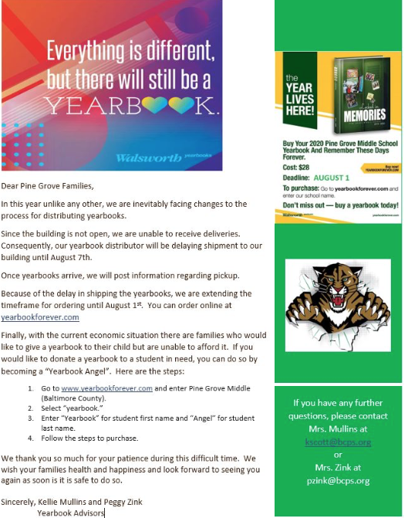
If you have any questions, please email Mrs. Mullins at kscott@bcps.org.

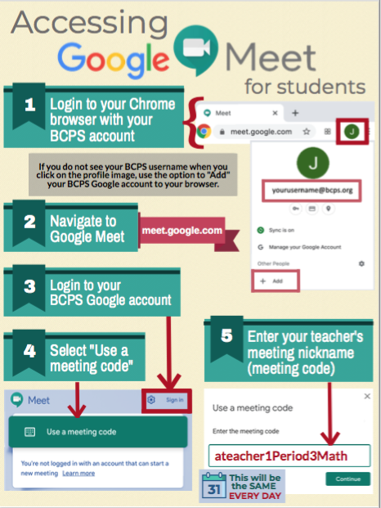

Full link to BCPS Continuity of Learning Plan (Copy & Paste into your browser):

https://www.bcps.org/system/coronavirus/Continuity_of_Learning_Plan.pdf

Link for social and emotional support for the BCPS Community:
https://scs.bcps.org/departments/social_emotional_support
COMMUNICATION

In an effort to increase communication, PLEASE FOLLOW US ON:
Facebook at: facebook.com/pg/PineGroveMiddle

Twitter at: @PGMSinBCPS
Instagram at: pgms.bcps.

BCPS Website: https://pinegrovems.bcps.org

Comcast is offering free Internet for a limited time: See link below

https://corporate.comcast.com/press/releases/internet-essentials-low-income-broadband-coronavirus-pandemic

In alignment with the state-mandated extended closure of school buildings, Baltimore County Public Schools will distribute free meals to students through Monday, June 22, 2020.
Students will receive a breakfast, lunch, and snack on Monday through Wednesday. On Thursday, students will receive two breakfasts, two lunches, and two snacks for Thursday and Friday. Meals will no longer be distributed on Friday.

Meals will be distributed from the following locations. While students are encouraged to be present when picking up meals, accommodations will be made for students who are unable to be present.

Students do not have to be present to receive meals in the parking lots of the locations identified below on weekdays through Monday, June 22, from 11 a.m. to 1 p.m.

BCPS Locations

- Arbutus Elementary School
- Baltimore Highlands Elementary School
- Battle Grove Elementary School
- Berkshire Elementary School
- Carney Elementary School
- Carriage Hill Apartments
- Chadwick Elementary School
- Chesapeake High School
- Church Lane Elementary School
- Cove Village Apartments, Essex
- Deep Creek Middle School
- Deer Park Middle School
- Dulaney High School
- Dundalk Elementary School
- Dundalk High School
- Elmwood Elementary School
- Featherbed Elementary School
- General John Stricker Middle School
- Glyndon Elementary School
- Halstead Academy
- Hawthorne Elementary School
- Johnnycake Elementary School
- Kings Point Shopping Center in front of Kiddie Koach
- Lansdowne High School
- Logan Elementary School
- Middle River Middle School
- Milbrook Elementary School
- New Town High School
- Oakleigh Elementary School
- Owings Mills Elementary School
- Padonia Elementary School
- Parkville High School
- Pleasant Plains Elementary School
- Riverview Elementary School
- Rosedale Library
- Saddle Brooke Apartments
- Sandy Plains Elementary School
- Scotts Branch Elementary School
- Sollers Point Multi-Purpose Center
- Sparrows Point High School
- Stemmers Run Middle School
- St. Peter Evangelical Lutheran Church, Eastern Ave.
- Sussex Elementary School
- Westchester Elementary School
- Westland Gardens Apartments
- Whispering Woods Complex
- Winfield Elementary School
- Woodlawn Middle School
- Woodmoor Elementary School
- Woodmoor Shopping Center

