PGMS Week of May 18
Home of the Cougars

Dear Pine Grove Middle Families,

We have completed another week of Remote Learning! I want to thank all of the students, parents, staff and teachers who have worked very hard this week. We will continue with Remote Learning until June 22nd; please continue to check emails for updates. At this time please know that the school building is closed, no one is allowed on-site.

Principal Magness
Congratulations! Please join us in congratulating Mr. Carbin, Social Studies Teacher/ Department Chair, for receiving the TABCO Middle School Educator of the Year Award; and Mr. Snyder, Social Studies Teacher, for receiving the TABCO Rookie of the Year Award. We are extremely proud of both of these very talented teachers and are humbled to have them be a part of the Pine Grove Middle School Community!
Grade 8 Parents: In the coming weeks, information will be shared with you about an end of the year Virtual Celebration for our 8th grade students.
Access to PGMS Information will be forthcoming regarding access to the building for picking up instruments, personal items, etc.… BCPS is working on a plan for this. We will share with you as soon as possible. Thank you for your continued patience.
Team BCPS Updates – Grades: The BCPS website now includes information about end-of-year report cards and progress reports for students in Preschool through Grade 12, in alignment with the Continuity of Learning plan and remote learning environment. Please go to our Grades and Report Cards webpage.
For Grades 6 through 12, we have some additional announcements.
Middle school students in Grades 6 through 8 will receive a grade of “Pass” or “Fail” for marking periods 3 and 4, as well as a grade of “Pass” or “Fail” for the final grade.
Parent University- Free Virtual Workshops for Family Wellness

In collaboration with BCPSConnects, Parent University is offering free virtual workshops to families and staff, which can be found on the Parent University Schedule. The schedule will be updated often with new offerings and can be found on the bottom of our Parent University homepage.
The Office of Family and Community Engagement has launched a weekly newsletter to be shared with families. The FACEtime Home Edition will be sent out weekly.

Update about Google Meet Calls May 12, 2020

Dear BCPS families & staff,
In the interest of student safety and security, BCPS has turned off a feature in Google Meet that provides call-in information to participants. If your student must use a phone call to join a session, teachers have been given information to assist them in calling your student directly from Google Meet to invite them into the session. A resource guide titled “Parent’s Guide to Google Meet Calls” is available through your student’s teacher and online. This guide outlines receiving a call and using the mobile apps provided by Google. BCPS continues to enhance security, maintaining a focus on student safety and providing an opportunity for all students to participate in remote learning.

YEARBOOK: Hi Cougars! Back in September the talented PGMS yearbook staff designed a yearbook cover called “Locked in Memories”. Little did we know that March would bring such a change to our lives with social distancing and online school, as we stay at Home to Save Lives during the Covid-19 Pandemic. The 2019-2020 yearbook is filled with pictures of good times and dear friends, and a special message from the faculty to you. Please purchase a yearbook today! Supplies are limited, so don’t miss out! Yearbooks are on sale for $28 at yearbookforever.com. If you have any questions, please email Mrs. Mullins at kscott@bcps.org.

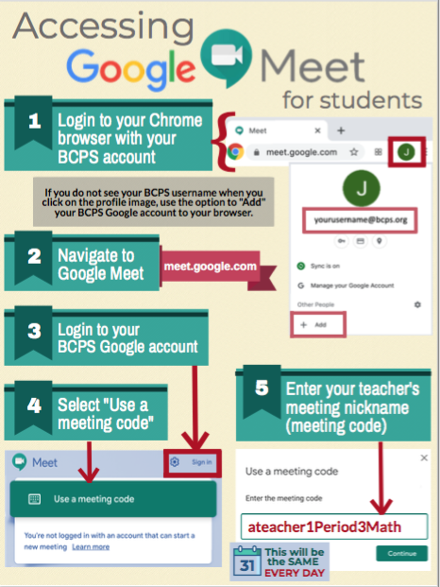

Full link to BCPS Continuity of Learning Plan (Copy & Paste into your browser):

https://www.bcps.org/system/coronavirus/Continuity_of_Learning_Plan.pdf

Link for social and emotional support for the BCPS Community:
https://scs.bcps.org/departments/social_emotional_support
COMMUNICATION

In an effort to increase communication, PLEASE FOLLOW US ON:
Facebook at: facebook.com/pg/PineGroveMiddle

Twitter at: @PGMSinBCPS
Instagram at: pgms.bcps.

BCPS Website: https://pinegrovems.bcps.org

Comcast is offering free Internet for a limited time: See link below

https://corporate.comcast.com/press/releases/internet-essentials-low-income-broadband-coronavirus-pandemic

In alignment with the state-mandated extended closure of school buildings, Baltimore County Public Schools will distribute free meals to students through Monday, June 22.
Students will receive a breakfast, lunch, and snack on Monday through Wednesday. On Thursday, students will receive two breakfasts, two lunches, and two snacks for Thursday and Friday. Meals will no longer be distributed on Friday.

Meals will be distributed from the following locations. While students are encouraged to be present when picking up meals, accommodations will be made for students who are unable to be present.

BCPS Locations

- Arbutus Elementary School
- Baltimore Highlands Elementary School
- Battle Grove Elementary School
- Berkshire Elementary School
- Carney Elementary School
- Carriage Hill Apartments
- Chadwick Elementary School
- Chesapeake High School
- Church Lane Elementary School (as of Thursday, Mar. 26)
- Cove Village Apartments, Essex, in front of rental office
- Deep Creek Middle School
- Deer Park Middle School
- Dulaney High School
- Dundalk Elementary School
- Dundalk High School
- Elmwood Elementary School
- Featherbed Elementary School
- General John Stricker Middle School
- Glyndon Elementary School
- Halstead Academy
- Hawthorne Elementary School
- Johnnycake Elementary School
- Kings Point Shopping Center in front of Kiddie Koach
- Lansdowne High School
- Logan Elementary School
- Middle River Middle School
- Milbrook Elementary School
- New Town High School
- Oakleigh Elementary School
- Owings Mills Elementary School
- Padonia Elementary School
- Parkville High School
- Pleasant Plains Elementary School
- Riverview Elementary School
- Rosedale Library
- Saddle Brooke Apartments
- Sandy Plains Elementary School
- Scotts Branch Elementary School
- Sollers Point Multi-Purpose Center
- Sparrows Point High School
- Stemmers Run Middle School
- St. Peter Evangelical Lutheran Church, Eastern Ave.
- Sussex Elementary School
- Westchester Elementary School
- Westland Gardens Apartments
- Whispering Woods Complex
- Winfield Elementary School
- Woodlawn Middle School
- Woodmoor Elementary School
- Woodmoor Shopping Center

