PGMS Week of May 11
Home of the Cougars

Dear Pine Grove Middle Families,

We have completed another week of Remote Learning! I want to thank all of the students, parents, staff and teachers who have worked very hard this week. As you know, Maryland State Department of Education has closed schools through June 22, 2020. We will continue with Remote Learning until the end of the school year; please continue to check emails for updates. At this time please know that the school building is closed, no staff members are on-site. Once the CDC, county health department and BCPS make decisions around reentry to the building, we will communicate that information and provide a schedule for students to obtain their items left at school.

Principal Magness
Team BCPS Updates – Grades, report cards, and graduations May 5, 2020
The BCPS website now includes information about end-of-year report cards and progress reports for students in Preschool through Grade 12, in alignment with the Continuity of Learning plan and remote learning environment. Please go to our Grades and Report Cards webpage.
For Grades 6 through 12, we have some additional announcements.
Middle school students in Grades 6 through 8 will receive a grade of “Pass” or “Fail” for marking periods 3 and 4, as well as a grade of “Pass” or “Fail” for the final grade.
YEARBOOK: Hi Cougars! Back in September the talented PGMS yearbook staff designed a yearbook cover called “Locked in Memories”. Little did we know that March would bring such a change to our lives with social distancing and online school, as we stay at Home to Save Lives during the Covid-19 Pandemic. The 2019-2020 yearbook is filled with pictures of good times and dear friends, and a special message from the faculty to you. Please purchase a yearbook today! Supplies are limited, so don’t miss out! Yearbooks are on sale for $28 at yearbookforever.com. If you have any questions, please email Mrs. Mullins at kscott@bcps.org.

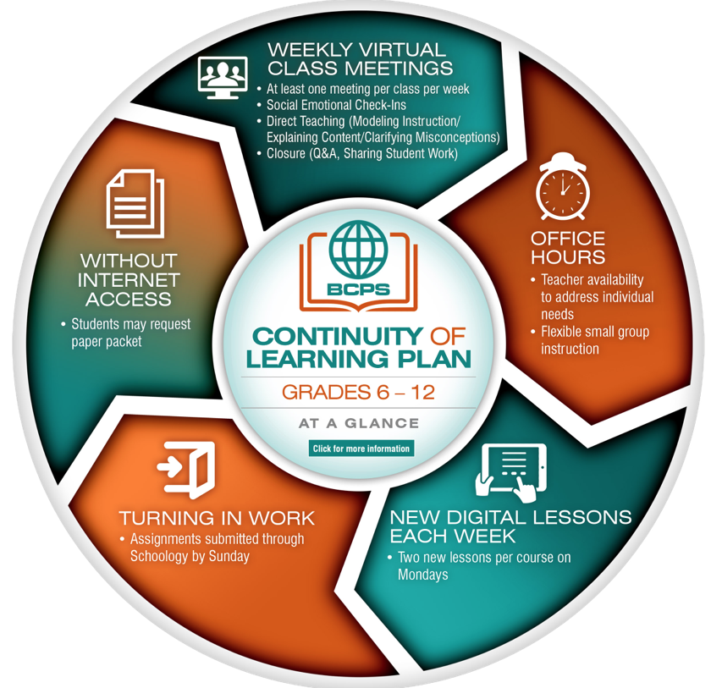

Full link to BCPS Continuity of Learning Plan (Copy & Paste into your browser):

https://www.bcps.org/system/coronavirus/Continuity_of_Learning_Plan.pdf

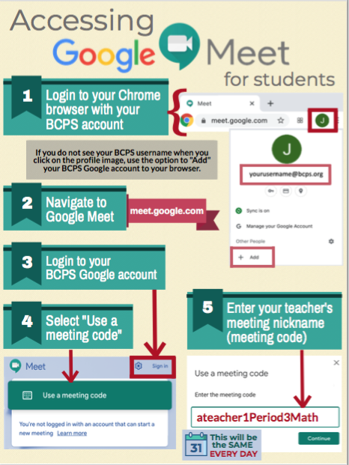

Link for social and emotional support for the BCPS Community:
https://scs.bcps.org/departments/social_emotional_support

COMMUNICATION

In an effort to increase communication, PLEASE FOLLOW US ON:
Facebook at: facebook.com/pg/PineGroveMiddle

Twitter at: @PGMSinBCPS
Instagram at: pgms.bcps.

BCPS Website: https://pinegrovems.bcps.org

Comcast is offering free Internet for a limited time: See link below

https://corporate.comcast.com/press/releases/internet-essentials-low-income-broadband-coronavirus-pandemic

In alignment with the state-mandated extended closure of school buildings, Baltimore County Public Schools will distribute free meals to students through Monday, June 22, 2020.
Students will receive a breakfast, lunch, and snack on Monday through Wednesday. On Thursday, students will receive two breakfasts, two lunches, and two snacks for Thursday and Friday. Meals will no longer be distributed on Friday.

Meals will be distributed from the following 58 locations. While students are encouraged to be present when picking up meals, accommodations will be made for students who are unable to be present. Please note the specific distribution times for each location. Times have been changed for some locations.

Students do not need to be present to receive meals in the parking lots of the locations identified below on weekdays through Monday, June 22, from 11 a.m. to 1 p.m.

BCPS Locations

- Arbutus Elementary School
- Baltimore Highlands Elementary School
- Battle Grove Elementary School
- Berkshire Elementary School
- Carney Elementary School
- Carriage Hill Apartments
- Chadwick Elementary School
- Chesapeake High School
- Church Lane Elementary School
- Cove Village Apartments, Essex, in front of rental office
- Deep Creek Middle School
- Deer Park Middle School
- Dulaney High School
- Dundalk Elementary School
- Dundalk High School
- Elmwood Elementary School
- Featherbed Elementary School
- General John Stricker Middle School
- Glyndon Elementary School
- Halstead Academy
- Hawthorne Elementary School
- Johnnycake Elementary School
- Kings Point Shopping Center in front of Kiddie Koach
- Lansdowne High School
- Logan Elementary School
- Middle River Middle School
- Milbrook Elementary School
- New Town High School
- Oakleigh Elementary School
- Owings Mills Elementary School
- Padonia Elementary School
- Parkville High School
- Pleasant Plains Elementary School
- Riverview Elementary School
- Rosedale Library
- Saddle Brooke Apartments
- Sandy Plains Elementary School
- Scotts Branch Elementary School
- Sollers Point Multi-Purpose Center
- Sparrows Point High School
- Stemmers Run Middle School
- St. Peter Evangelical Lutheran Church, Eastern Ave.
- Sussex Elementary School
- Westchester Elementary School
- Westland Gardens Apartments
- Whispering Woods Complex
- Winfield Elementary School
- Woodlawn Middle School
- Woodmoor Elementary School
- Woodmoor Shopping Center

