PGMS Week of April 27
Home of the Cougars

Dear Pine Grove Middle Families,

We have completed another week of Remote Learning! I want to thank all of the students, parents, staff and teachers who have worked very hard this week. At this time please know that the school building is closed, no staff are on-site.

Principal Magness
This information will be helpful if you are having trouble with the microphone on the device:

Windows 10 Microphone
When using the built-in or an external microphone in Windows 10 sometimes the signal may be muted. This will give an error that the application cannot “hear” or see activity from the microphone. Or there will simply be nothing recorded in an application.
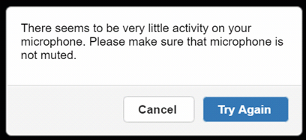

- Right-click the Speaker Icon in the bottom right-hand side of the system tray.
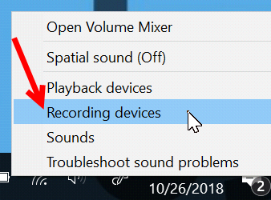
- Select Recording Devices from the menu options.

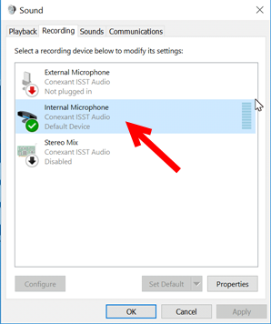
- Double-click the microphone or recording device in use. The example below shows the internal microphone.

- Click the Levels Tab (1) and then make sure that there is not a mute indication on the small speaker icon (2).
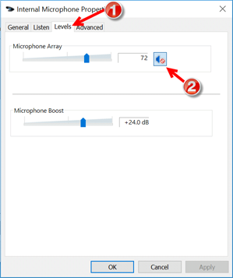

- Click the icon to remove the muting.
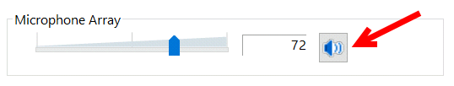

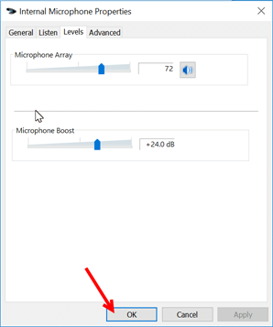
6. Click the OK button to save the changes.

If you would like to have printed packets of materials sent to your home for your child, please visit this website to complete this request:

Link for students in grades 6-12:
https://docs.google.com/forms/d/e/1FAIpQLSdjdWINulyDwze7FYPdT6RN6apA7yYTGBtqwWsOX8AyMaC1YQ/viewform?usp=sf_link

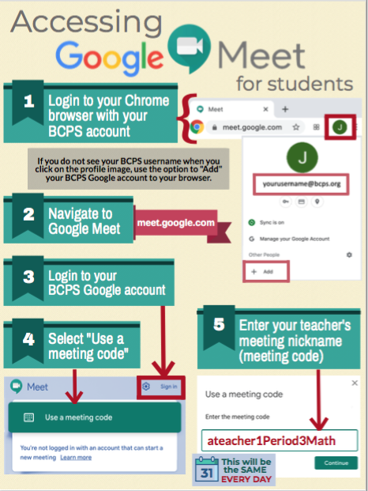

Link for social and emotional support for the BCPS Community:
https://scs.bcps.org/departments/social_emotional_support

YEARBOOK: Hi Cougars! Back in September the talented PGMS yearbook staff designed a yearbook cover called “Locked in Memories”. Little did we know that March would bring such a change to our lives with social distancing and online school, as we stay at Home to Save Lives during the Covid-19 Pandemic. The 2019-2020 yearbook is filled with pictures of good times and dear friends, and a special message from the faculty to you. Please purchase a yearbook today! Supplies are limited, so don’t miss out! Yearbooks are on sale for $28 at yearbookforever.com. If you have any questions, please email Mrs. Mullins at kscott@bcps.org.

COMMUNICATION

In an effort to increase communication, PLEASE FOLLOW US ON:
Facebook at: facebook.com/pg/PineGroveMiddle

Twitter at: @PGMSinBCPS
Instagram at: pgms.bcps.

BCPS Website: https://pinegrovems.bcps.org

Comcast is offering free Internet for a limited time: See link below

https://corporate.comcast.com/press/releases/internet-essentials-low-income-broadband-coronavirus-pandemic

In alignment with the state-mandated extended closure of school buildings, Baltimore County Public Schools will distribute free meals to students through Friday, May 15.
Beginning April 20, students will receive a breakfast, lunch, and snack on Monday through Wednesday. On Thursday, students will receive two breakfasts, two lunches, and two snacks for Thursday and Friday. Meals will no longer be distributed on Friday.

Students do not need be present to receive meals in the parking lots of the locations identified below on weekdays through Thursday, May 14, 2020.

BCPS Locations

- Arbutus Elementary School
- Baltimore Highlands Elementary School
- Battle Grove Elementary School
- Berkshire Elementary School
- Carney Elementary School
- Carriage Hill Apartments
- Chadwick Elementary School
- Chesapeake High School
- Church Lane Elementary School (as of Thursday, Mar. 26)
- Cove Village Apartments, Essex, in front of rental office
- Deep Creek Middle School
- Deer Park Middle School
- Dulaney High School
- Dundalk Elementary School
- Dundalk High School
- Elmwood Elementary School
- Featherbed Elementary School
- General John Stricker Middle School (as of Thursday, Mar. 26)
- Glyndon Elementary School
- Halstead Academy
- Hawthorne Elementary School
- Johnnycake Elementary School
- Kings Point Shopping Center in front of Kiddie Koach
- Lansdowne High School
- Logan Elementary School
- Middle River Middle School
- Milbrook Elementary School
- New Town High School
- Oakleigh Elementary School
- Owings Mills Elementary School
- Padonia Elementary School
- Parkville High School
- Pleasant Plains Elementary School
- Riverview Elementary School
- Rosedale Library
- Saddle Brooke Apartments
- Sandy Plains Elementary School
- Scotts Branch Elementary School
- Sollers Point Multi-Purpose Center
- Sparrows Point High School
- Stemmers Run Middle School
- St. Peter Evangelical Lutheran Church, Eastern Ave.
- Sussex Elementary School
- Westchester Elementary School
- Westland Gardens Apartments
- Whispering Woods Complex
- Winfield Elementary School
- Woodlawn Middle School
- Woodmoor Elementary School
- Woodmoor Shopping Center

