PGMS Week of April 13
Home of the Cougars

Dear Pine Grove Middle Families,

We have completed our first week of Remote Learning! There have been some technology challenges and some “new learning” challenges as we worked hard to transition to this new way of learning for your children, but overall, we met with much success. I want to thank all of the students, parents, teachers and staff who have worked very hard this week to support the Remote Learning process. I know I have sent a lot of communication over the last two weeks, but it is important that you know information in a timely manner.

BCPS is recognizing Good Friday and Easter Monday, so schools and offices (remotely) are closed. At this time please know that the school building is closed, no staff are on-site.

Lastly, please take time this weekend, to disconnect and take care of yourselves and your family. We miss seeing our PGMS family in person!

Principal Magness

If you are in need of printed packets of materials for your child, please visit this website to complete the request for material form:

Link for students in grades 6-12:
https://docs.google.com/forms/d/e/1FAIpQLSdjdWINulyDwze7FYPdT6RN6apA7yYTGBtqwWsOX8AyMaC1YQ/viewform?usp=sf_link

Access Your Teacher’s Google Meet!
During our remote teaching throughout the 4th quarter, BCPS teachers will use Google Meet to host virtual class sessions at scheduled times and to host office hours to meet with both students and parents. Students can join a Google Meet from any computer or phone by using the Meet App or dialing into the Meet (some features will not be available to students when they call in). It is important that the utilize their BCPS credential (log in) to join the groups.

How to Join
- Go to your course on Schoology.
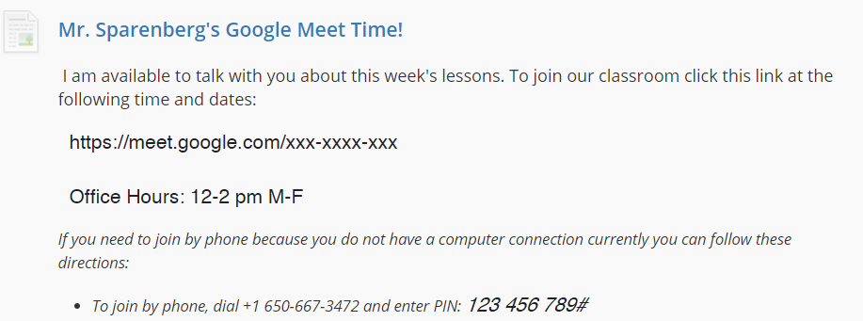
- Find the section with your teacher’s Google Meet information.
- Access the Meet using one of the following methods during your scheduled meeting time.
  - Use the provided hyperlink.
  - Call the provided number and enter the provided pin (make sure you insert use the # key.)

- If prompted by the filter, sign in with your BCPS username and password.
- If prompted, allow Google Meet computer to use both your microphone and camera.
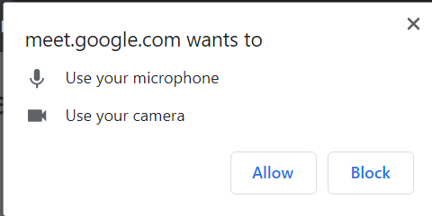

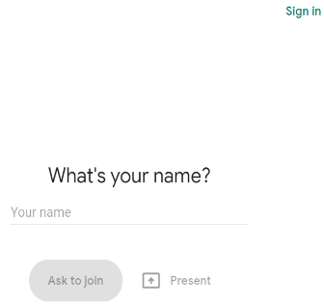
- In the top right corner of the screen click the Sign In button.
- Sign into the Google Meet with your BCPS Google Account.Your Google account is the same account you use for OneDrive: your BCPS email (ex. JJS032@bcps.org) and your internal password.
- Click the Join Now button.
- Enjoy your Google Meet with your teacher and classmates!

How students will need to Log into Chrome with BCPS Credentials
When they are using a Non-BCPS Device
In order to Access Google Meets

- You must be in the Chrome Browser
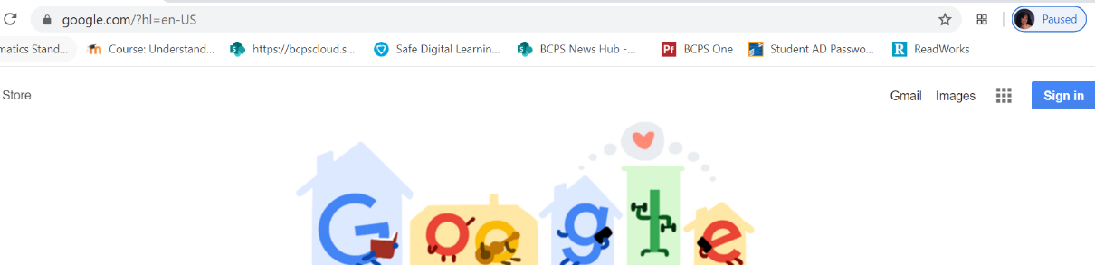
2.
- Click Sign in.

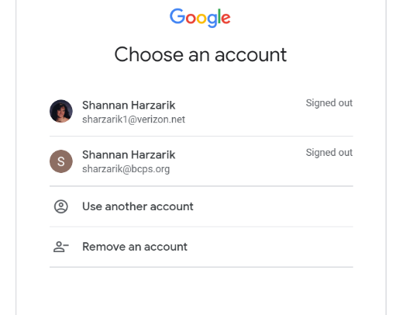
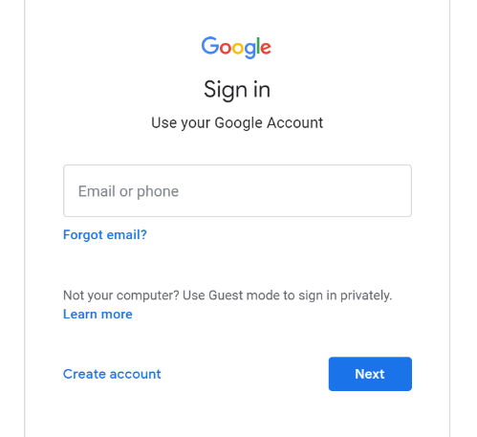
- You will then be brought to one of 2 screens. The 1st one is if someone in your household already has an account, if so click on use another account and it will take you to second one. If no one has an account on the device you will automatically be taken to the 2nd screen.

4. enter username@bcps.org

- Students will enter their BCPS username with @bcps.org as their “email”.

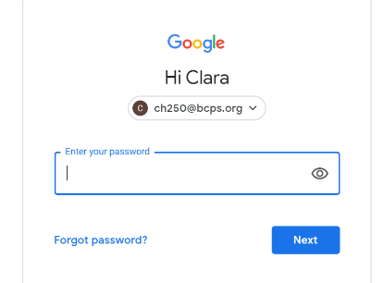
- The student will now enter their password:
5.

You can now follow the Google Meets directions to log into a meeting.

Link for social and emotional support for the BCPS Community:
https://scs.bcps.org/departments/social_emotional_support

YEARBOOK: Hi Cougars! Back in September the talented PGMS yearbook staff designed a yearbook cover called “Locked in Memories”. Little did we know that March would bring such a change to our lives with social distancing and online school, as we stay at Home to Save Lives during the Covid-19 Pandemic. The 2019-2020 yearbook is filled with pictures of good times and dear friends, and a special message from the faculty to you. Please purchase a yearbook today! Supplies are limited, so don’t miss out! Yearbooks are on sale for $28 at yearbookforever.com. If you have any questions, please email Mrs. Mullins at kscott@bcps.org.

COMMUNICATION

In an effort to increase communication, PLEASE FOLLOW US ON:

Facebook at: facebook.com/pg/PineGroveMiddle
Twitter at: @PGMSinBCPS
Instagram at: pgms.bcps.

BCPS Website: https://pinegrovems.bcps.org

Comcast is offering free Internet for a limited time: See link below

https://corporate.comcast.com/press/releases/internet-essentials-low-income-broadband-coronavirus-pandemic

In alignment with the state-mandated extended closure of school buildings, Baltimore County Public Schools will distribute free meals to students through Friday, April 24.
Beginning Thursday, Mar. 26, BCPS students may pick up breakfast, lunch, and dinner (three meals in one bag) at 50 locations. Please continue to check the BCPS Coronavirus Updates webpage for the latest list.
Students no longer need to be present to receive meals in the parking lots of the locations identified below on weekdays through Friday, Apr. 24, from 11 a.m. to 1 p.m.
BCPS Locations

- Arbutus Elementary School
- Baltimore Highlands Elementary School
- Battle Grove Elementary School
- Berkshire Elementary School
- Carney Elementary School
- Carriage Hill Apartments
- Chadwick Elementary School
- Chesapeake High School
- Church Lane Elementary School (as of Thursday, Mar. 26)
- Cove Village Apartments, Essex, in front of rental office
- Deep Creek Middle School
- Deer Park Middle School
- Dulaney High School
- Dundalk Elementary School
- Dundalk High School
- Elmwood Elementary School
- Featherbed Elementary School
- General John Stricker Middle School (as of Thursday, Mar. 26)
- Glyndon Elementary School
- Halstead Academy
- Hawthorne Elementary School
- Johnnycake Elementary School
- Kings Point Shopping Center in front of Kiddie Koach
- Lansdowne High School
- Logan Elementary School
- Middle River Middle School
- Milbrook Elementary School
- New Town High School
- Oakleigh Elementary School
- Owings Mills Elementary School
- Padonia Elementary School
- Parkville High School
- Pleasant Plains Elementary School
- Riverview Elementary School
- Rosedale Library
- Saddle Brooke Apartments
- Sandy Plains Elementary School
- Scotts Branch Elementary School
- Sollers Point Multi-Purpose Center
- Sparrows Point High School
- Stemmers Run Middle School
- St. Peter Evangelical Lutheran Church, Eastern Ave.
- Sussex Elementary School
- Westchester Elementary School
- Westland Gardens Apartments
- Whispering Woods Complex
- Winfield Elementary School
- Woodlawn Middle School
- Woodmoor Elementary School
- Woodmoor Shopping Center

