**PGMS Week of October 5**

**Home of the Cougars**

Dear Pine Grove Middle Families,

This week I have witnessed many of our parents, teachers, staff, community members and administrators continuing to work hard to provide our students with the tools they need for remote learning. We are proud of our school community and we will continue to provide support for our students and families.

Principal Magness

**Dates to Remember:**

Friday, October 16 MSTA Convention for Teachers, **Schools closed for students**

**Tech Support (for Parents & Students)**

The BCPS online support portal is <https://bcpsone.bcps.org/support/>.

Families can place support tickets in this location or call 443-809-4672.

**The Help Desk Technology Support Services** (for Teachers, Parents, and Students)

Phone Number: 443-809-4672. Open Monday – Friday 7:00 a.m. to 4:15 p.m. BCPS Serve tickets can be put in 24/7. Please record your service ticket number for reference.

**Wednesday Attendance**: Please have your child follow the directions below for all the “Independent Work Wednesdays.” Thank you.

1. Log into Schoology
2. Log into any class to complete classwork/activities
3. After logging into the class, your child will be marked present
4. This must be done before 2:00 PM or your attendance will not be counted.



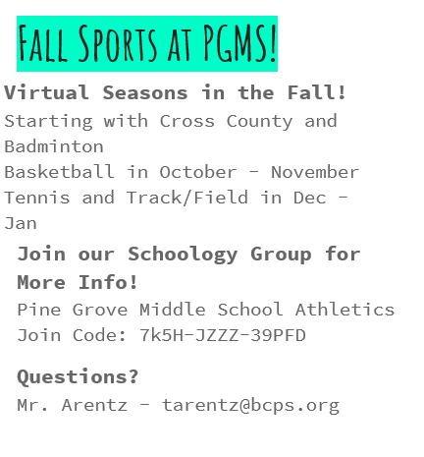

**Pine Grove Middle School Sports Page**: <https://docs.google.com/forms/d/e/1FAIpQLSe9Lx3cUaxjD2--yhI3eXAGYlSa5m2bvCXJd4bC13vTw5VSrQ/viewform>

**Attention Grade 8 Parents- 2021-2022 Magnet Application Cycle**:

[Magnet Brochures](https://dci.bcps.org/cms/One.aspx?portalId=9047042&pageId=31811586) for the 2021-2022 school year are now available.  
Applications for the 2021-2022 school year were posted on  
September 16, 2020.

The application deadline is November 6, 2020.  
  
[Wait Lists](https://dci.bcps.org/department/educational_options/educational_opportunities/magnet_programs/application_and_admissions/wait_lists) for the 2020-2021 school year will remain active  
until November 13, 2020.  
  
See upcoming [Magnet Events](https://dci.bcps.org/department/educational_options/educational_opportunities/magnet_programs/events) and register for the Application Information Meetings!

**Magnet School-based Video Showcases and Live Virtual Events**

***(For updates to this list, please visit the*** [***magnet programs website***](https://dci.bcps.org/cms/One.aspx?portalId=9047042&pageId=66601089)***.)***

**Pine Grove Middle School is a Food pick- up center** for our community.  Pick up times are Mondays and Wednesdays from 11:00-12:30 in front of Pine Grove Middle.

On our school website PGMS Website: <https://pinegrovems.bcps.org>

you will find needed information:

* Remote Learning Schedules by grade
* Weeks with Wednesday changes
* Device support information
* And much more!

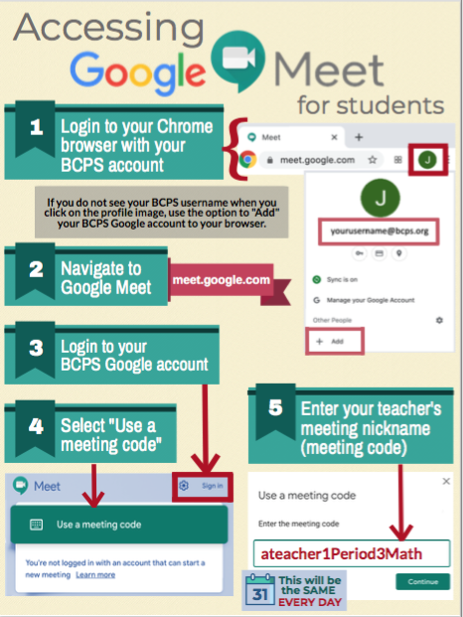

**COMMUNICATION**

In an effort to increase communication, PLEASE FOLLOW US ON:



Facebook at: facebook.com/pg/PineGroveMiddle



Twitter at: @PGMSinBCPS



Instagram at: pgms.bcps.

